**Department of Computer Systems Engineering**

**University of Engineering and Technology**

**Peshawar, Pakistan**

**Communication Systems (MidTerm Exam), Fall 2020**

**Time Allowed: 02 Hours, Total Marks 150, Weightage: 20%**

* Attempt any 15 questions, ALL questions carry equal marks.
* Read the complete paper in the first 15 minutes and get your queries (if any) clarified within this time; No question will be entertained after this time. Moreover, if you feel any data missing, you can assume any reasonable values for it.

1. ~~Differentiate analog and digital signals.~~
2. ~~Briefly define the purpose of MODAM at transmitter and receiver.~~
3. ~~How much signal power attenuated if its amplitude is 5V at the transmitter and the channel transfer function h = 0.8?~~
4. ~~Differentiate attenuation and distortion.~~
5. ~~What should be the sampling rate for the formation of the PCM signal?~~
6. ~~What is quantization error? And how it can be minimized?~~
7. ~~What effect occurs on data volume if quantization error reduces?~~
8. ~~Find SNR at the output of the receiver if received signal power is 10 watts and noise is 0 Db.~~
9. What will be the offered capacity of a channel for GSM system? Use SNR value calculated from the above problem.
10. ~~How BW related to the data rate? Calculate data rate for a GSM system.~~
11. ~~Briefly describe the needs of modulation~~.
12. ~~Find the power of the signal below.~~

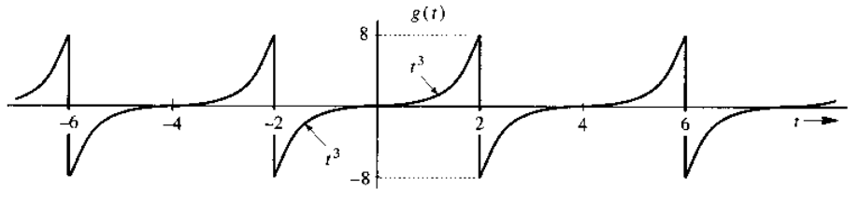

1. ~~Draw x(0.5t – 0.5) and x(1.5t – 2.5) for a signal below.~~

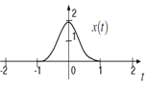

1. ~~What are the properties of impulse function? How can we get the channel state information?~~
2. ~~Sketch g(0.5t - 4), g(3t/1.5), g(2.5t - 8) and g(2 - t) for a figure given below.~~

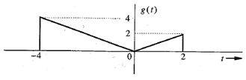

1. ~~Describe how co-channel cells can be located in cellular systems if i = 2, and j = 1?~~